**Lab6 - Testing Document**

**Testno#1**: Create Database ‘student_db’

Create database student_db;

**Result : successful**

**Testno#2(a)**: Run the application

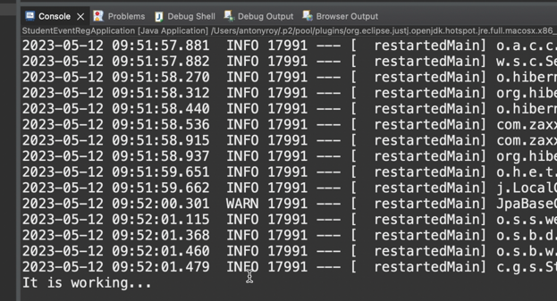

**Result: successful**

**TestNo#2(b):** Run the following db scripts to update the userid,password

and also set the roles for two users – ‘kumar’ as ‘ADMIN & ‘amit’ as ‘USER’

USE STUDENT_DB;

-- Create users kumar & amit password set to 123

insert into USERS(user_id,password,username) values (1,'$2a$04$WaWnqzosZ.cH7XBUkHn94eZ/4DeLhAw.06OReR4/0JhDtfodn6ZGO','kumar')

insert into USERS(user_id,password,username) values (2,'$2a$04$WaWnqzosZ.cH7XBUkHn94eZ/4DeLhAw.06OReR4/0JhDtfodn6ZGO','amit')

--Create two roles ADMIN and USER

INSERT INTO ROLES(role_id,name) values (1,'ADMIN');

INSERT INTO ROLES(role_id,name) values (2,'USER');

--Assign roles kumar as ADMIN & amit as USER

INSERT INTO USERS_ROLES(user_id,role_id) values(1,1);

INSERT INTO USERS_ROLES(user_id,role_id) values(2,2);

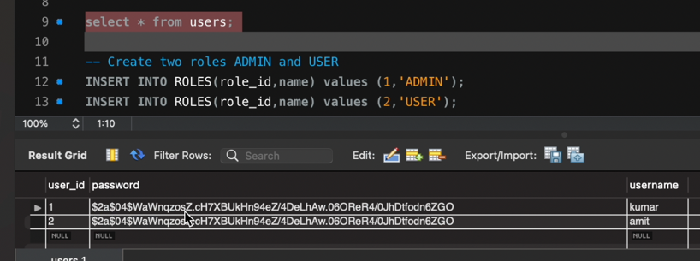

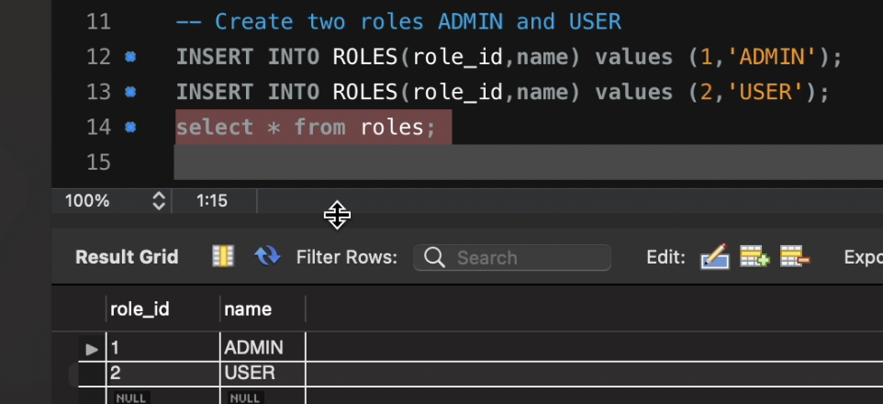

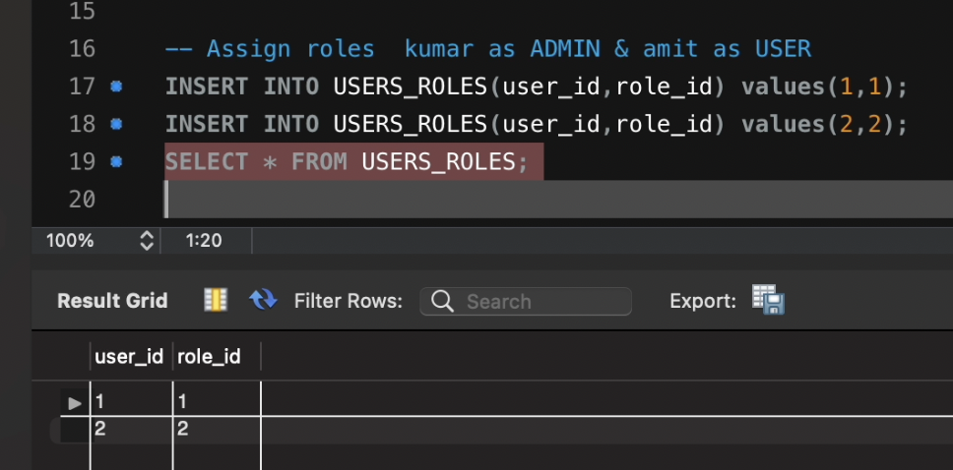

**Result:Successful**

**Testno# 3** : Check Authentication

Checking the password kumar and amit

Login as a kumar (role: admin )

Test 3(a) Enter a valid password 123, it should launch the application

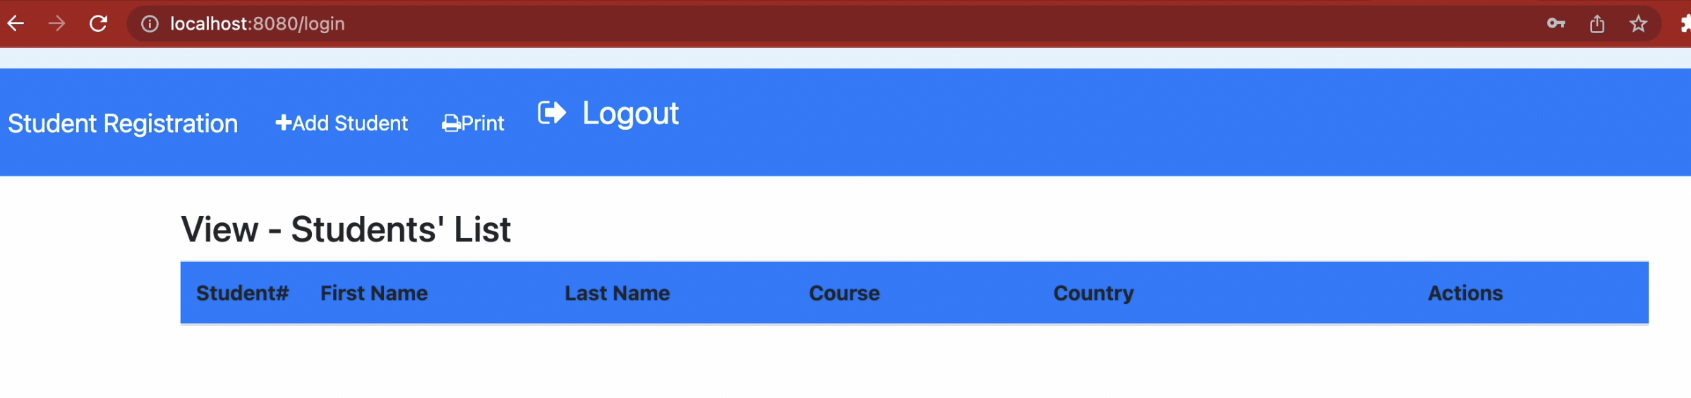

**Result:Successful**

Test 3(b) Enter wrong password, it should show the error message

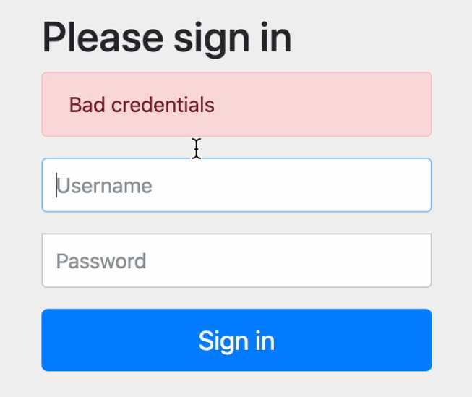

**Result : Successful**

TestNo#4(a) : Check Authorization ‘ADMIN’ role

|  |  |  |
| --- | --- | --- |
| username | Password | Role |
| Kumar | 123 | ADMIN |
| Amit | 123 | USER |

Login as ‘kumar’ (role is ‘ADMIN’)

**TestNo#4(b):**

Click on ‘Add Student’ button, should be able add following students

|  |  |  |  |  |
| --- | --- | --- | --- | --- |
| **Student Id** | **FirstName** | **LastName** | **Course** | **Country** |
| 1 | Suresh | Reddy | B.Tech | India |
| 2 | Murali | Mohan | B.Arch | Canada |

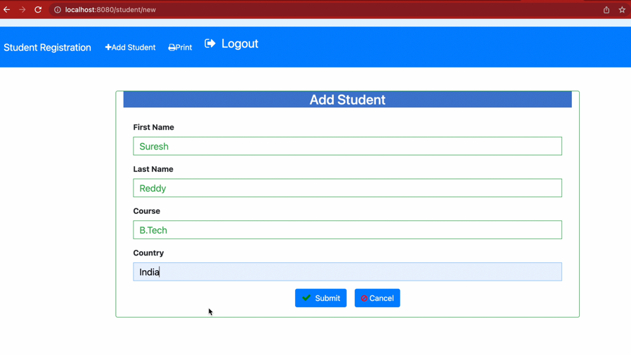

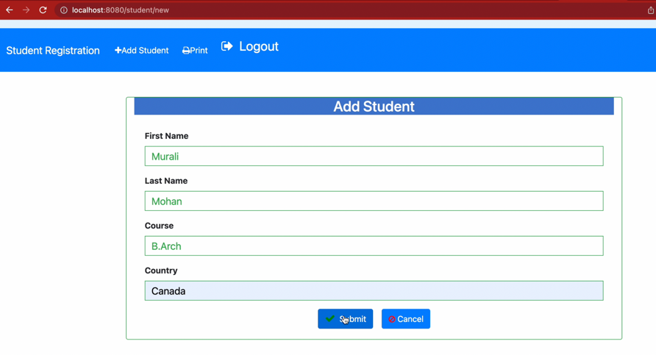

The list shows the two students recently added

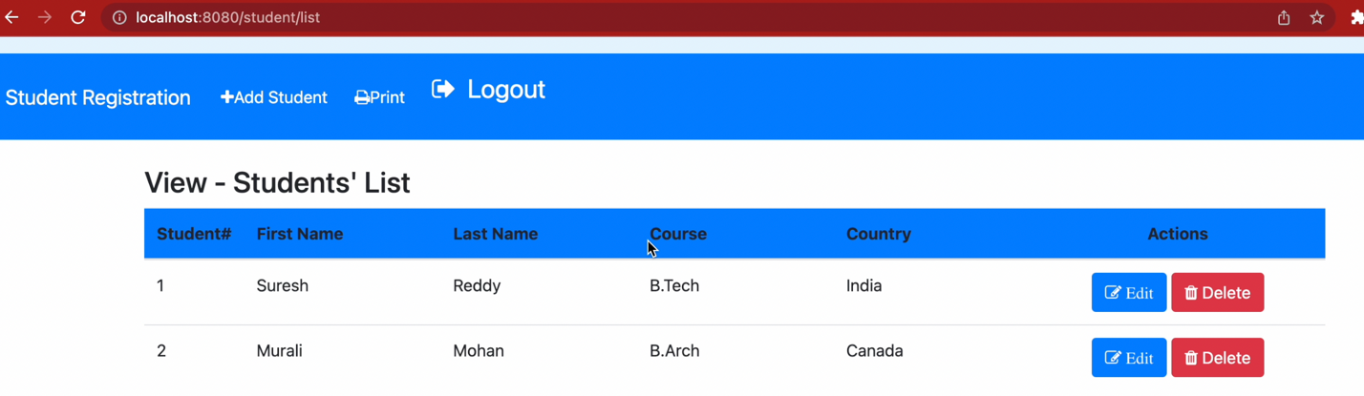

Checking the database

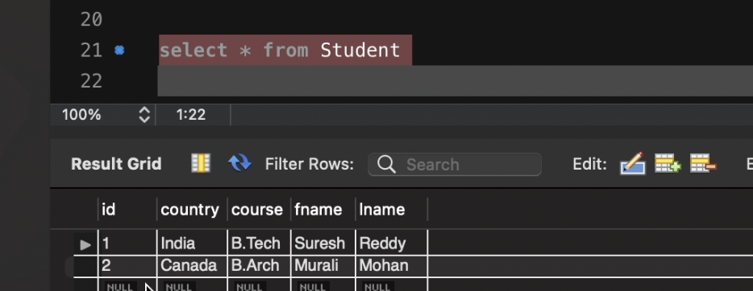

**TestNo#4(c):**Click on ‘Edit’ button, should be able to edit the records and save in the database

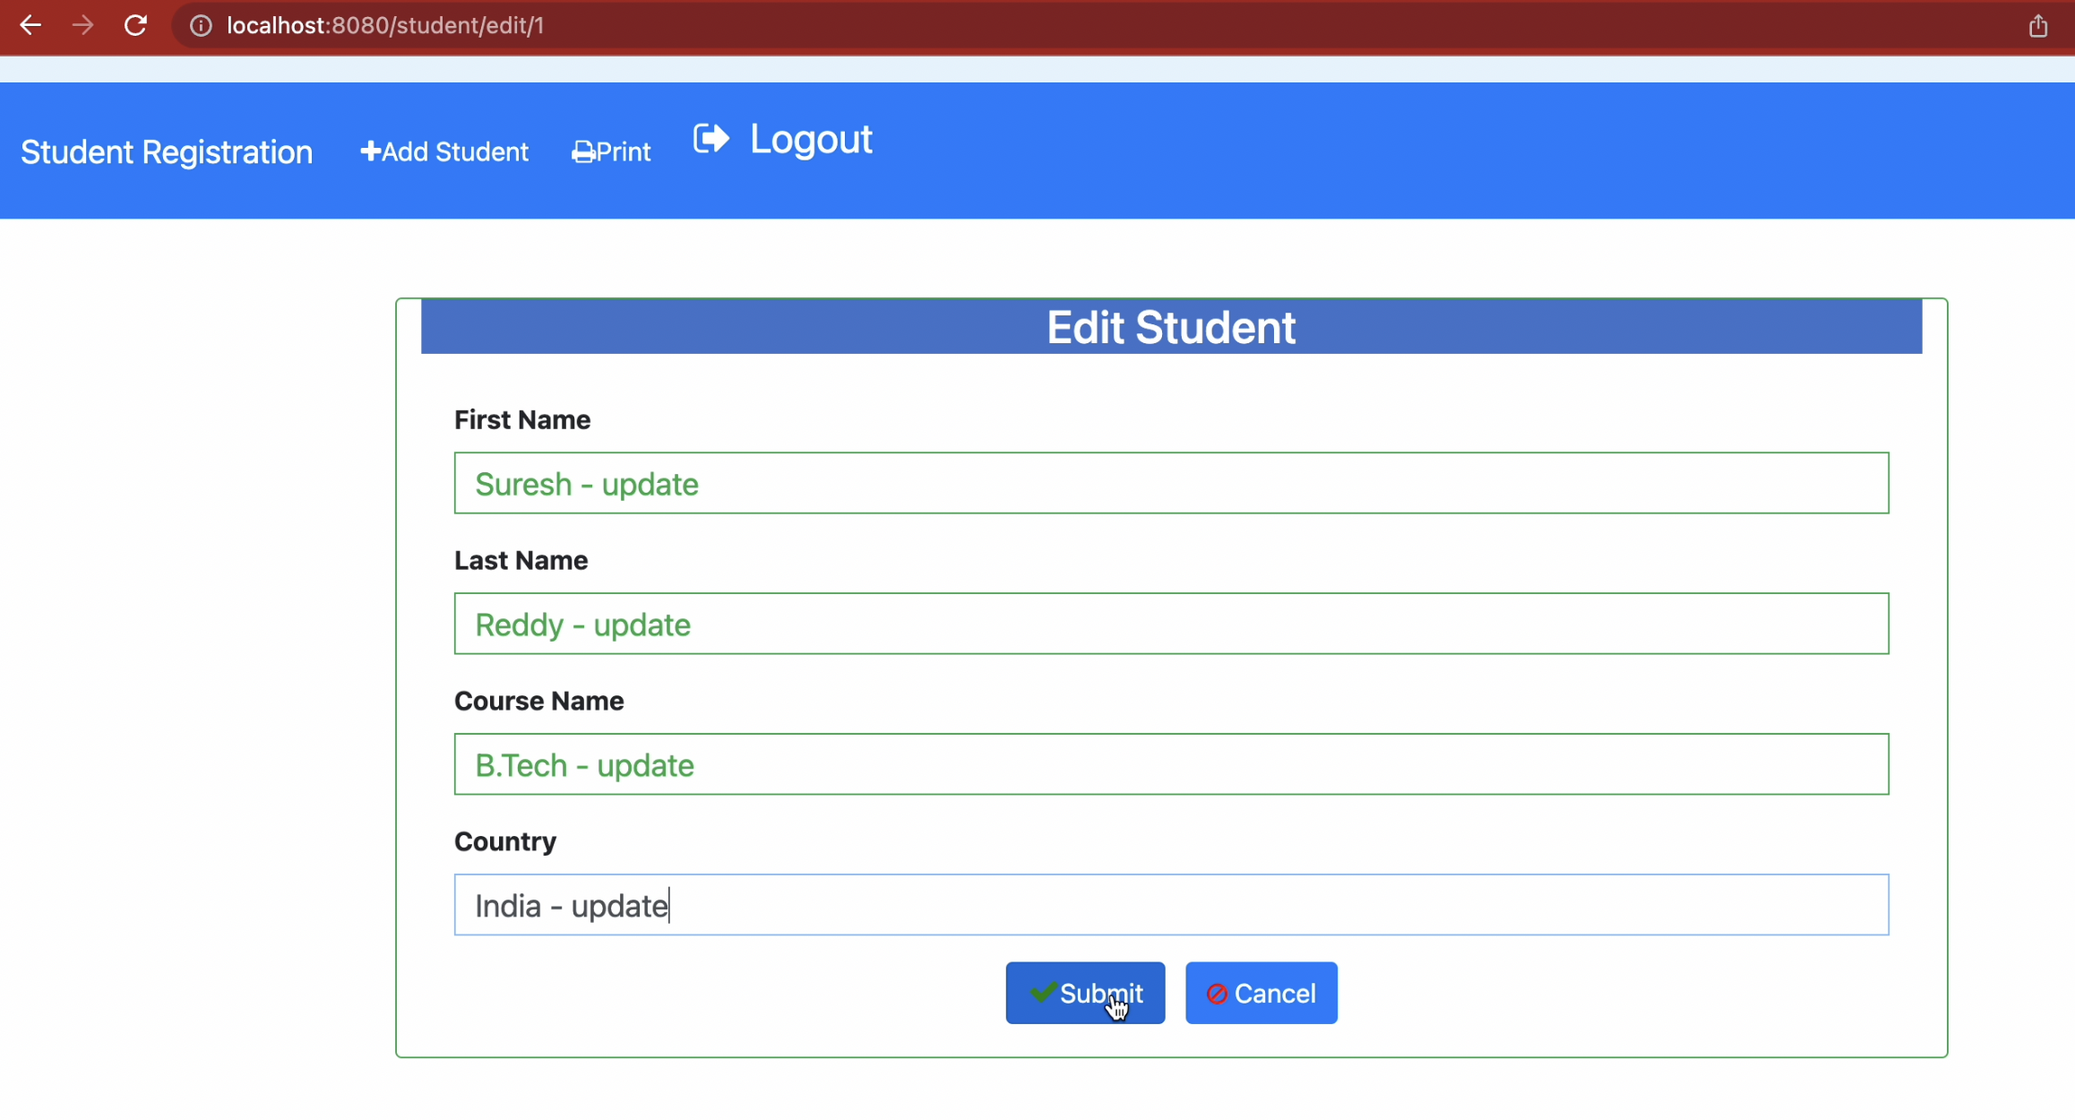

The list shows the updated the values

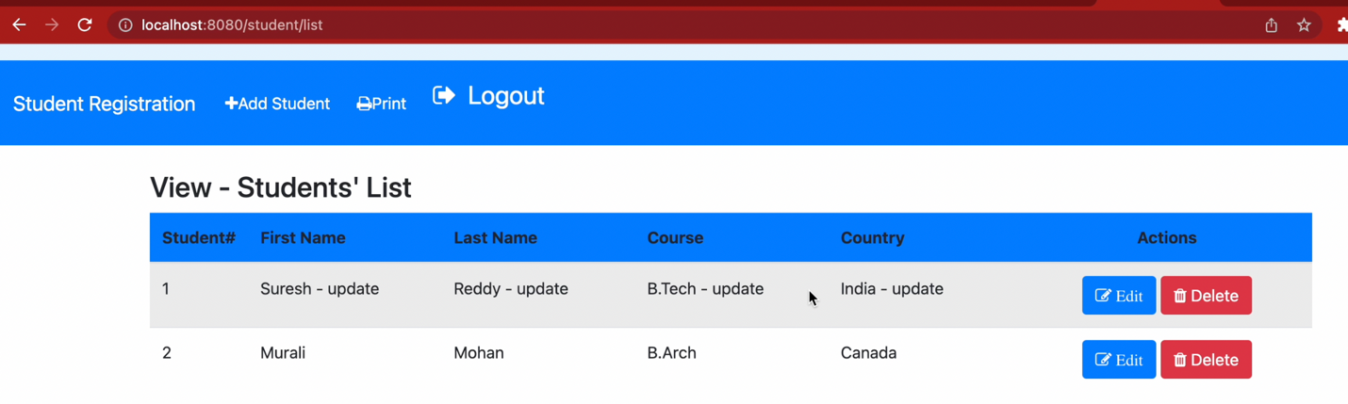

Check the database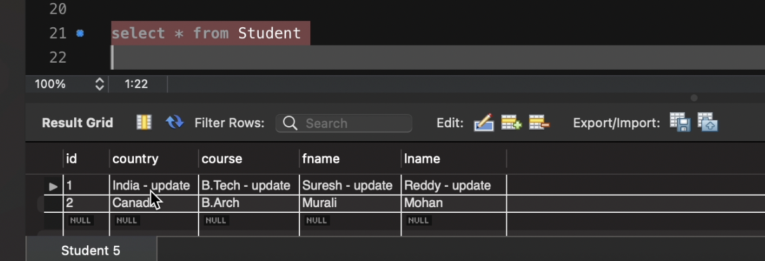

**Result: Successful**

**TestNo#4(d):**

Click on ‘Delete’ button to remove a student from the list

Click on delete button of studentid#1

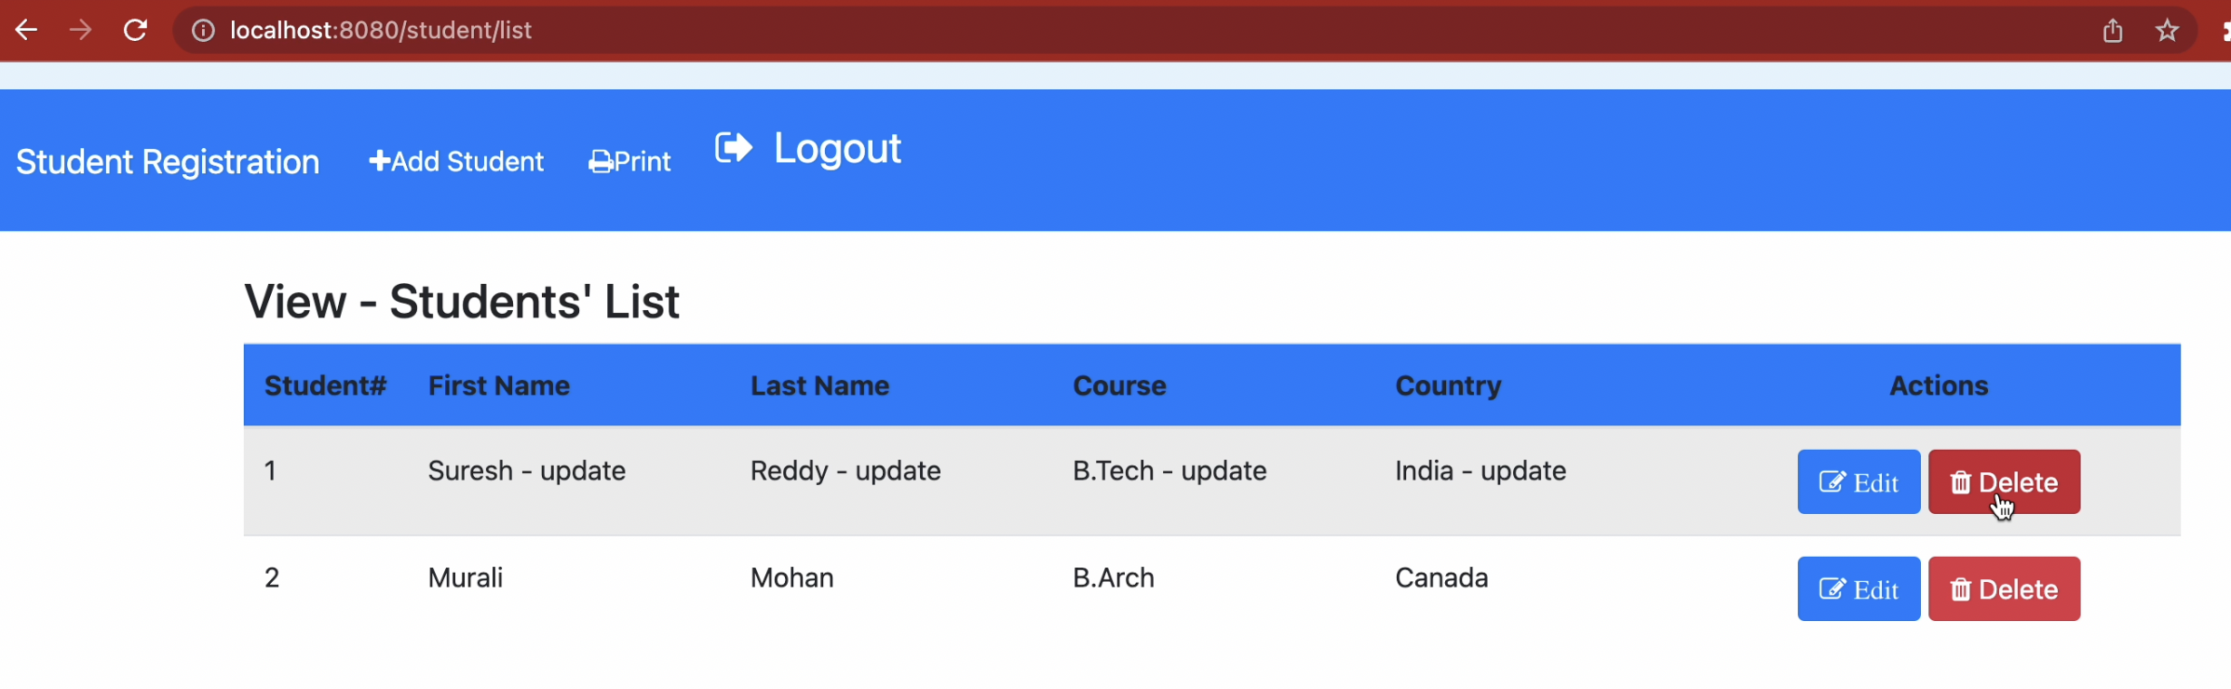

After deletion it refreshes the list

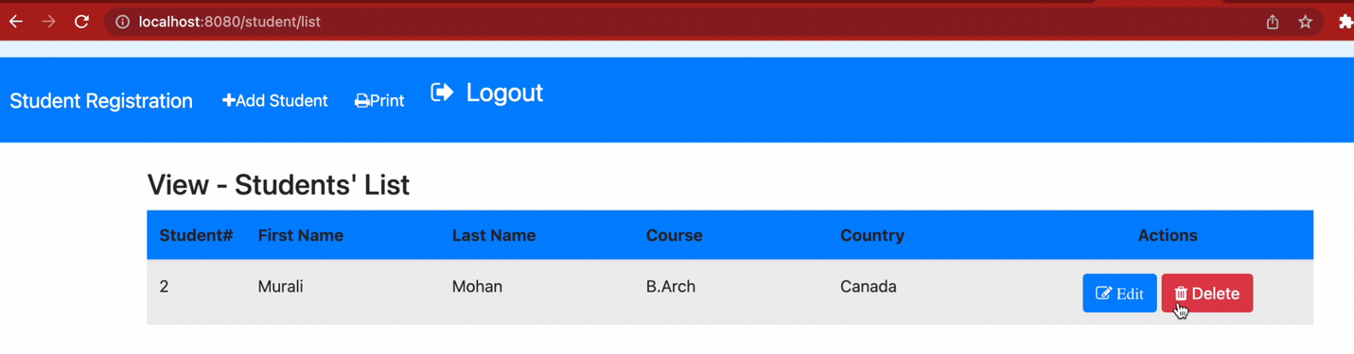

Data is removed from the student table

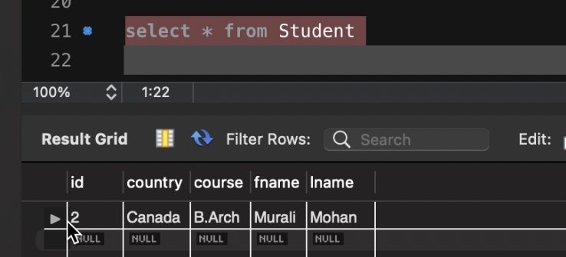

**Result:Successful**

**TestNo#4(e**):Click on ‘Print’ button, it should list out all the students and be able to print records

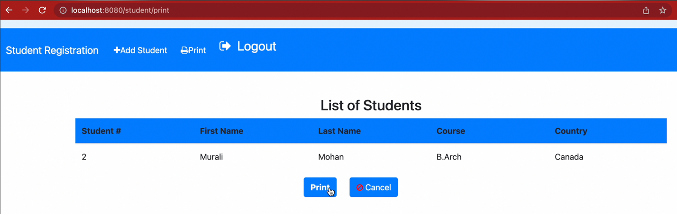

And if you click on the click button it will open up the print option

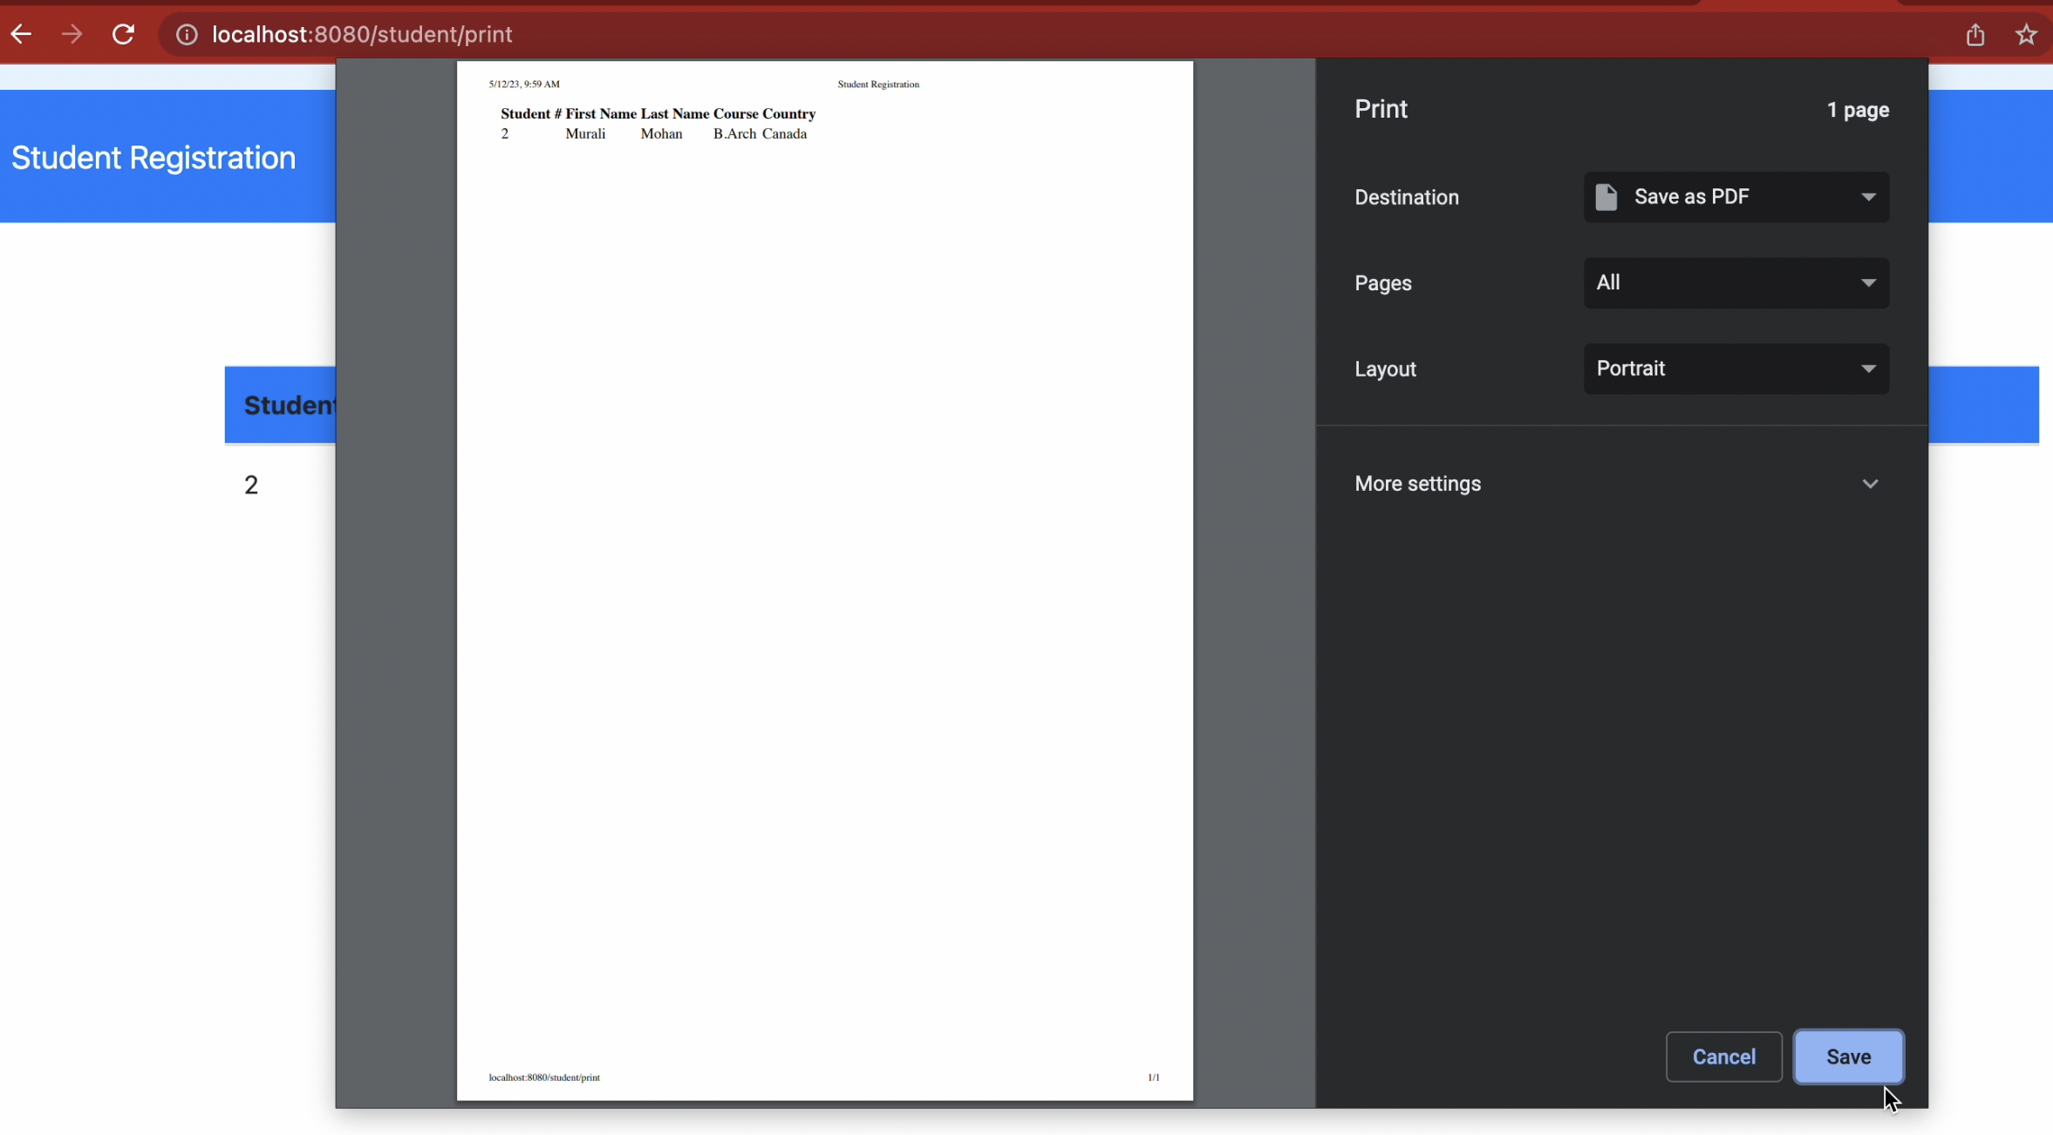

**Result: Successful**

**TestNo#5(a)** Check authorization (USER role)

Login as amit (amit is a USER role)

Password: 123

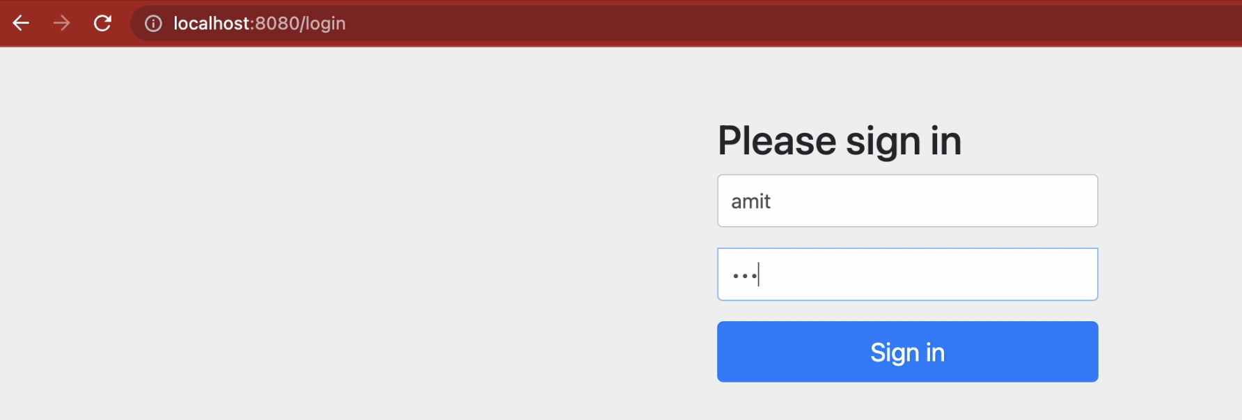

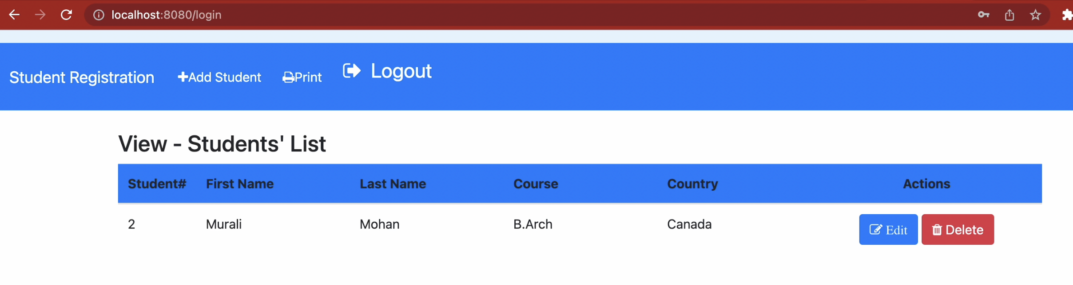

Result : Successful

**TestNo#5(b):**

Click on ‘Add Student’ button, should be able add students with the USER role

|  |  |  |  |  |
| --- | --- | --- | --- | --- |
| **Student Id** | **FirstName** | **LastName** | **Course** | **Country** |
| 3 | Daniel | Denson | B.Tech | New Zealand |
| 4 | Tanya | Gupta | B.Com | USA |

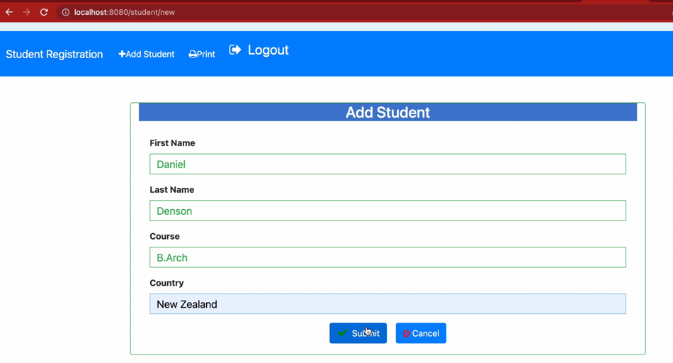

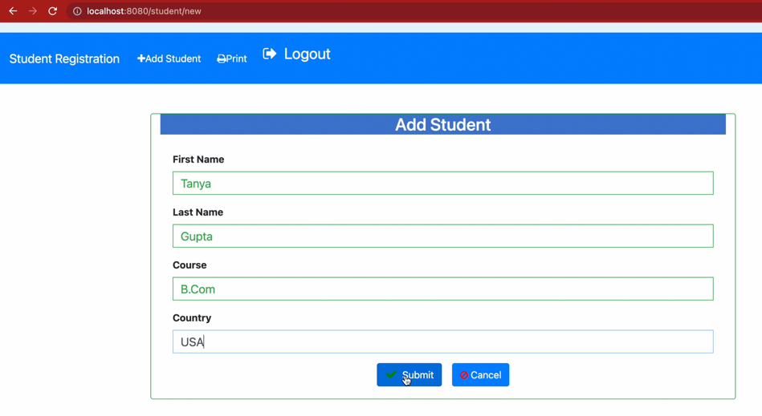

After adding two records it refreshes the list

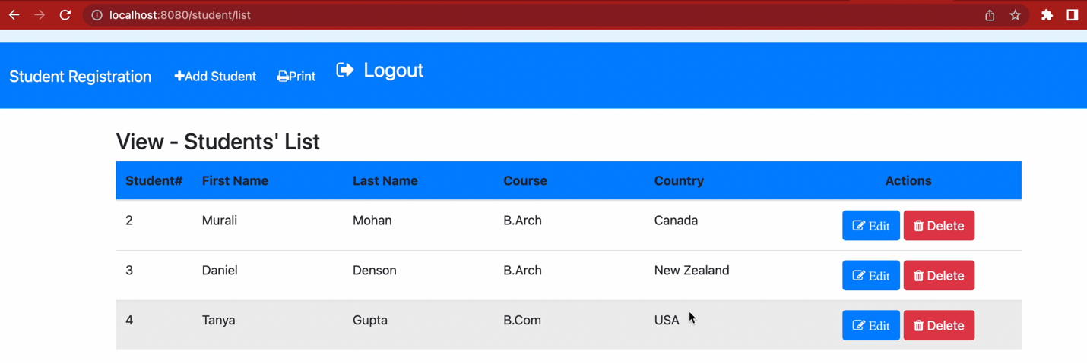

**Result:Successful**

**TestNo#5(c)**

Click on ‘Edit’ button, it should not allow the user to edit the data

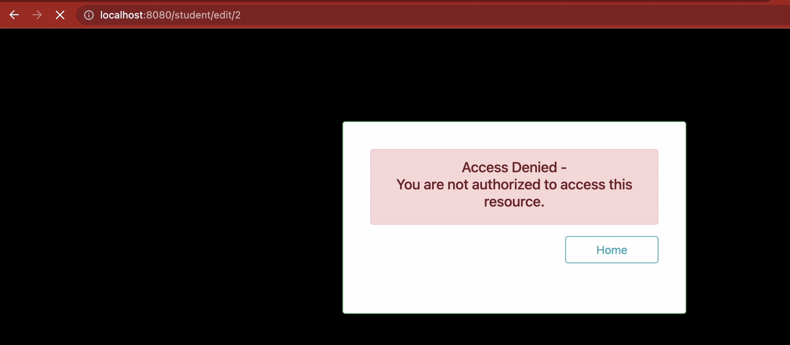

**Result:Successful**

**TestNo#5(d):**

Click on ‘Delete’ button, it should not allow the user to delete the data

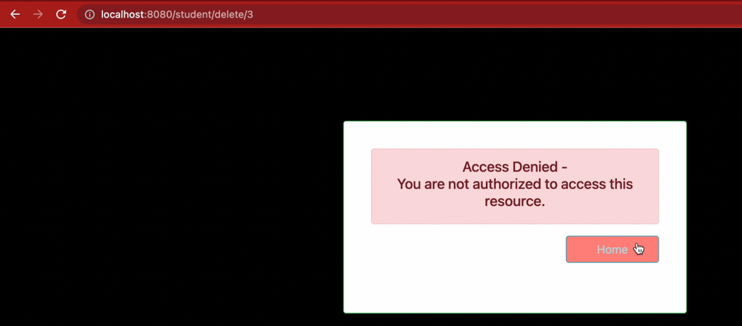

**Result:Successful**

**TestNo#5(e):**

Click on ‘Print’ button, it should not allow the user to print the data

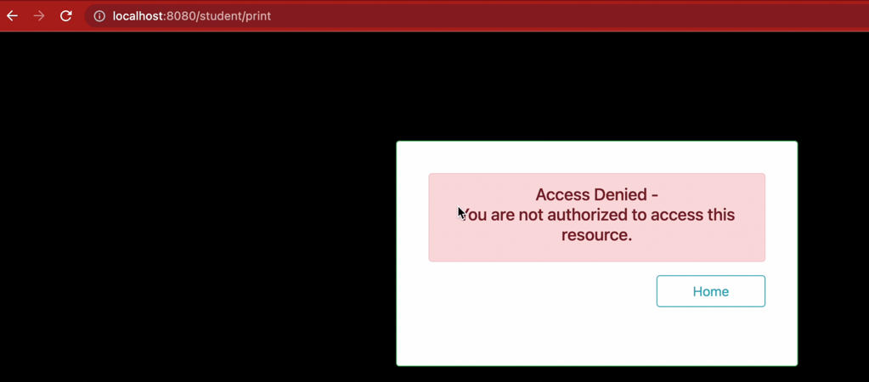

**Result:Successful**

**TestNo#6:**Check the logout functionality and comes to the login page

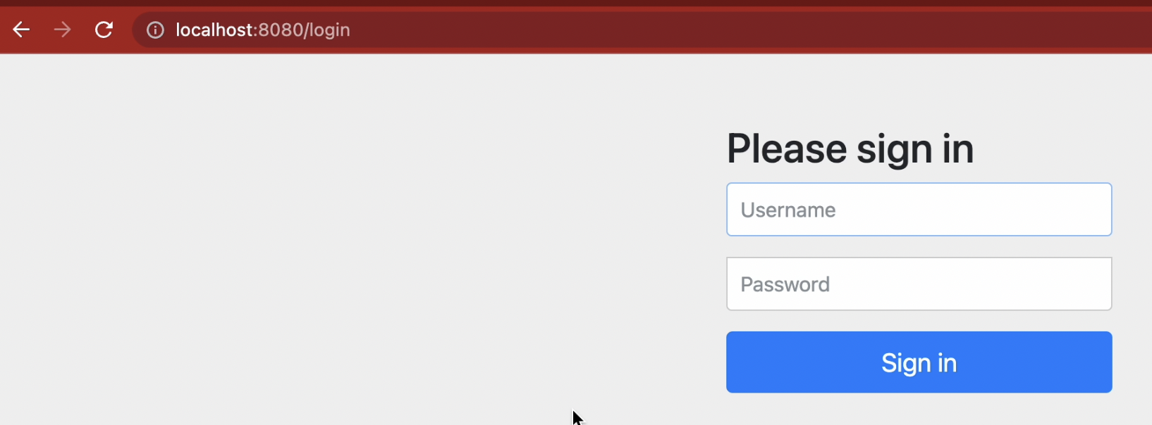

**Result:Successful**

**TestNo#7**: Try to check the session by giving different link.

Enter any /student/delete directly into the address bar to check the successful logout.

It should go to the login page



**Result:Successfully logged out.**